# User Documentation

## System Overview

Medical organisations provide people with many services. Because of the increase of population in the last few years, there is overdependence on medical institutions and more demand for services. As a result, the LS Hospital has initiated an online website of a warehouse which provides people with many services and facilities. People can browse the website to see the available products and detailed information about each product such as availability, usage, price and production and expiry dates.

Many people can use the websites such patients and employee and managers. Patients buy the product by filling in with essential information, choosing the products and sending the order. The transaction is very easy and practical, and it saves their time and effort. Employees can facilitate the process and ensure that it complies with the rules. They can also edit information about the product such as price and off stock.

This system is an improvement in the field of medicine and healthcare. By using automation and the most recent technology. It enables people to benefit from the website while they are at home in a very flexible way and more efficiently than the previous method as well as saving their time and effort.

## Using the system

**NOW,** I will talk about GUI which stands for Graphical user interface and it allows the user to interact with software or data base by using graphical icons, dialog box, buttons, text field and windows so we can consider the GUI the front interface for our software. It helps any user of the system the system not just the customer, maybe the employee, manager, CEO. I will explain our GUI for ls_hospital system and each page in it, and how the user uses these pages in the right way. Any user of the system should create an account. After the user create the account, he/she will see the home page which presents the pages which he/she can see and this depends on the responsibility of each user on each page.

**Home Page**

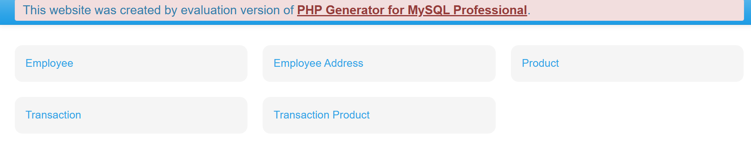

This is the home page for the employee. he can see this page after creating an account and entering the website. This page shows many pages and each one has different information. The employee has different privileges on each page. If the employee clicks on any name of the page, it will open.

**Employee page**

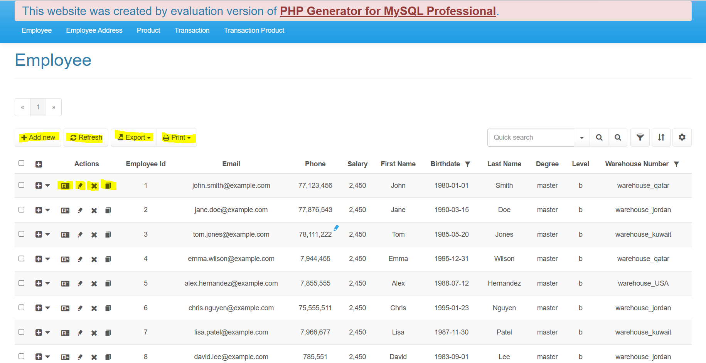

the employee will see his/her information in this page. If the employee wants to insert the information, he/she should click on  button, and then the page bellow will appear. Each text field should be filled with data depending on what is written next to it, then clicks on save button.

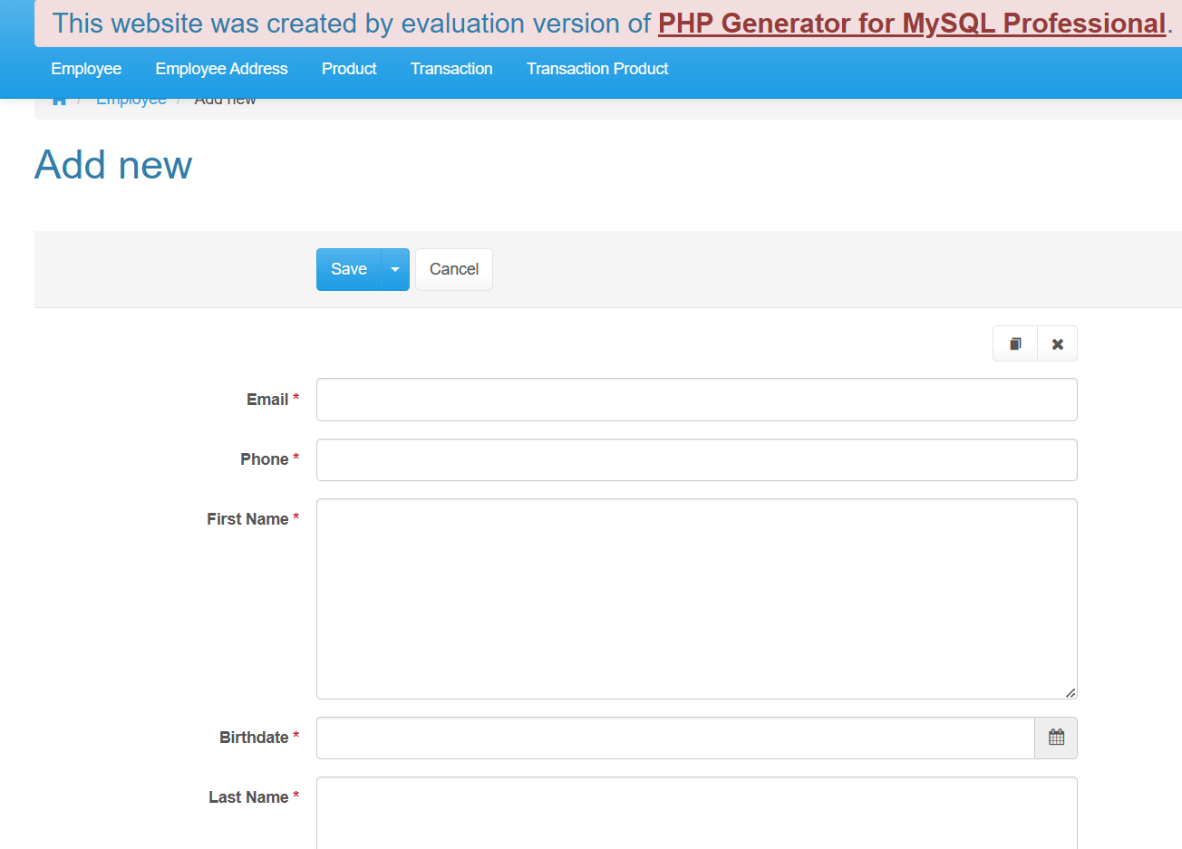

 🡪 means the data should be filled and not empty 🡪 

If the employee doesn’t want to insert data, he/she should click on cancel button 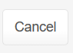 then return to employee page where all the data appears.

If the employee wants to print or export her/his information, he/she should click on button 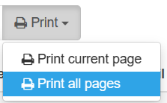 then choose print the current page or print all pages. Also, he can click on export button 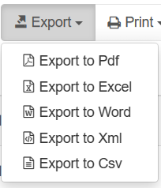 then choose how he wants to export it.

If the employee wants to view the data, he/she should click on view button  then he/she will see the information.

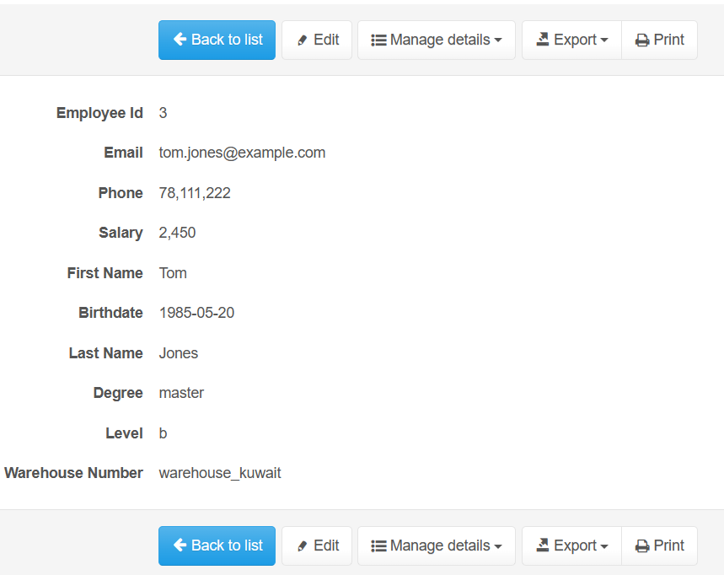

From this page he/ she can do many privileges such as edit, export, or print. If the employee clicks on the manage details button  he/ she will see this page.

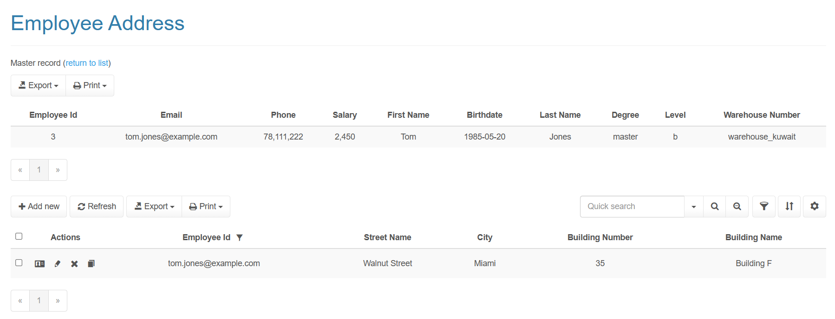

Which means that he can see detailed data such as the address of the employee.

If the employee wants to edit his/her information, he/she should click on edit button  then this page will appear to edit the information

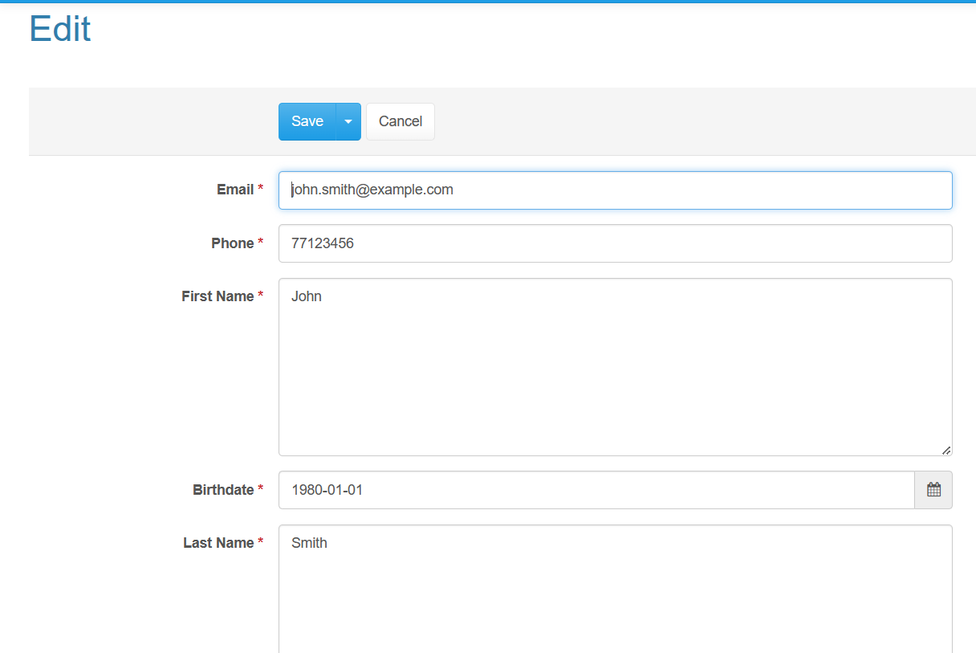Then click on save button.

**Employee address page**

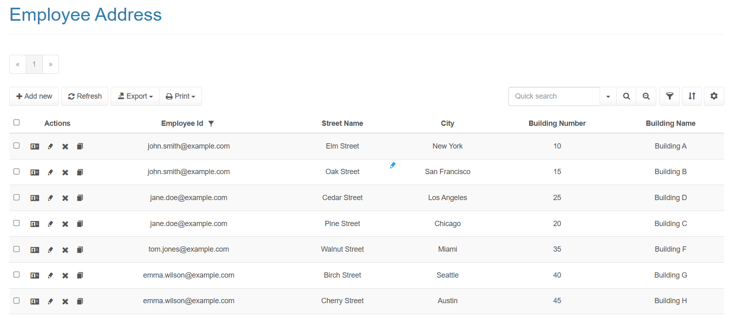

In this page the employee will see his/her information. If the employee wants to insert the address information, he/she should click on  button, and then the page bellow will appear. Each text field should be filled with data depending on what is written next to it then clicks on save button.

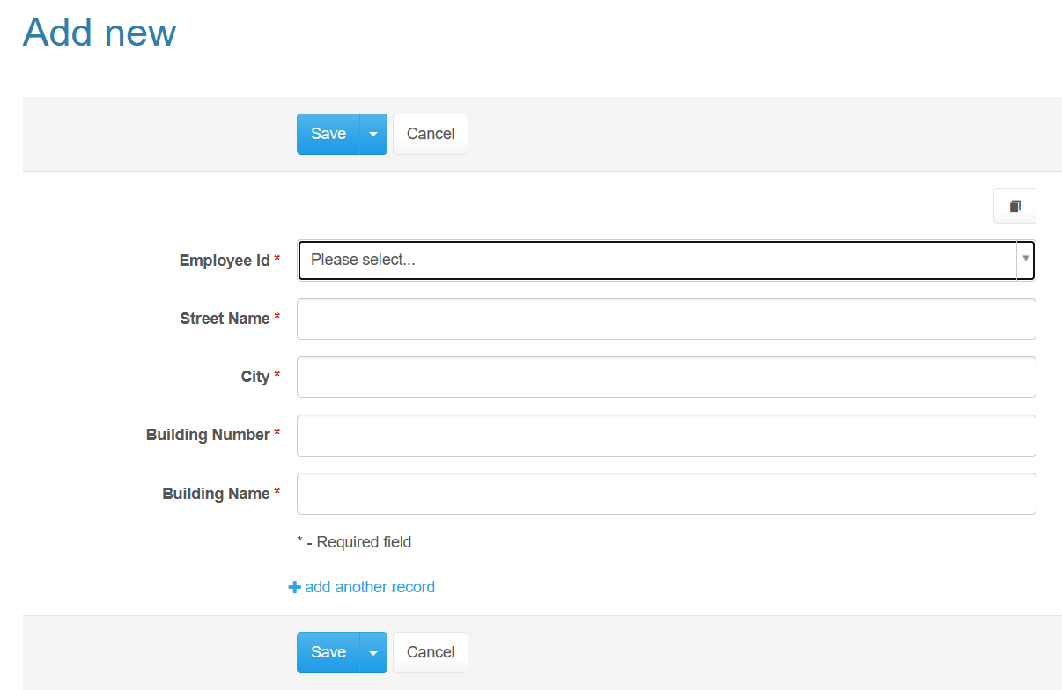

then return to employee page where all the data appears.

button , then choose print the current page or print all pages. also, he can click on export button  then choose how he wants to export it.

If the employee wants to view the data, he/she should click on view button  then he/she will see the information.

If the employee wants to edit his/her information, he/she should click on edit button  then this page will appear to edit the information.

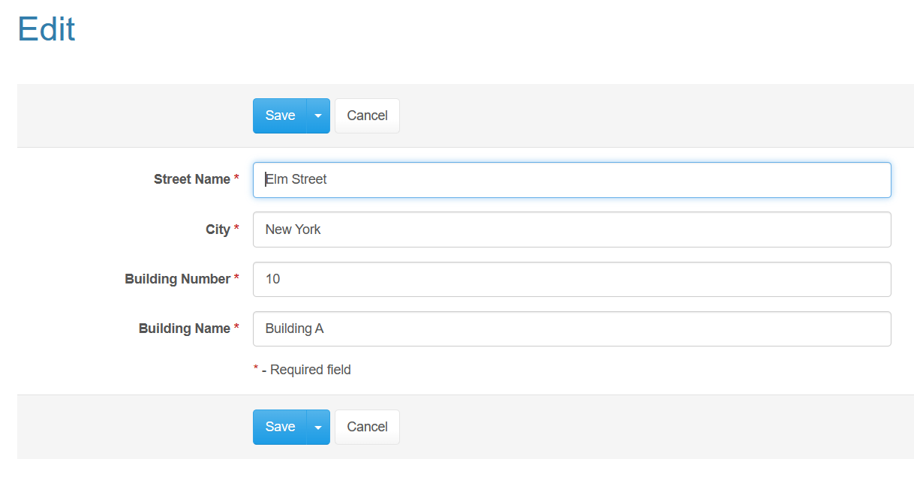

**Product page**

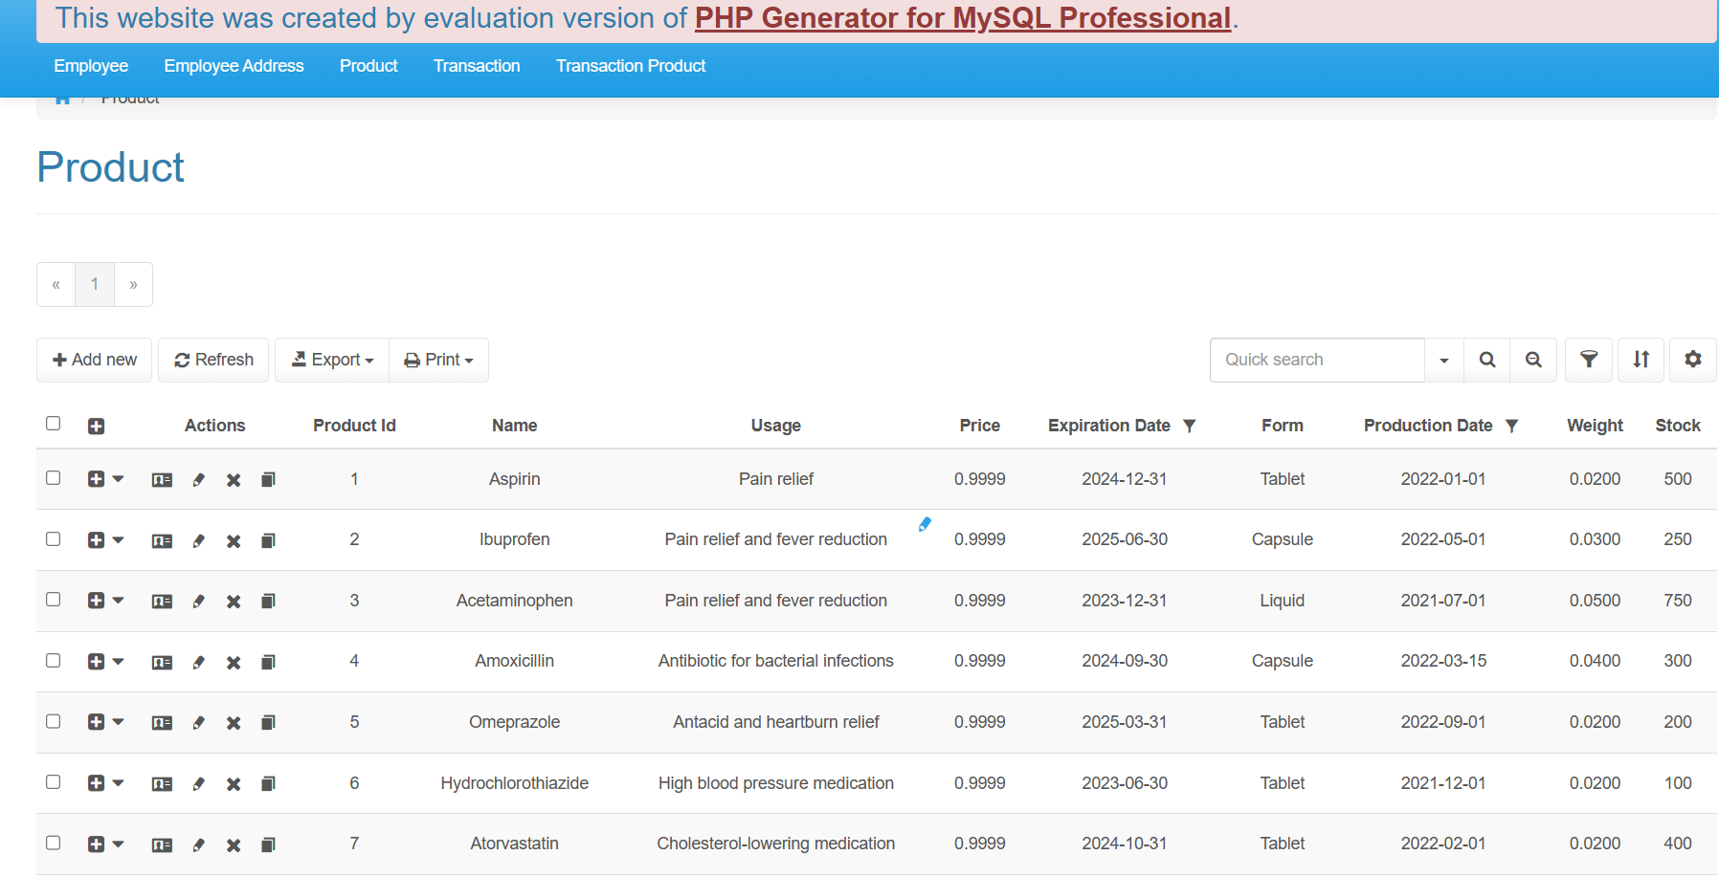

In this page the employee can insert, view, update, delete, or print all information of the product by using the icons and buttons in the page.



In case the employee wants to insert the information, the page below will appear.

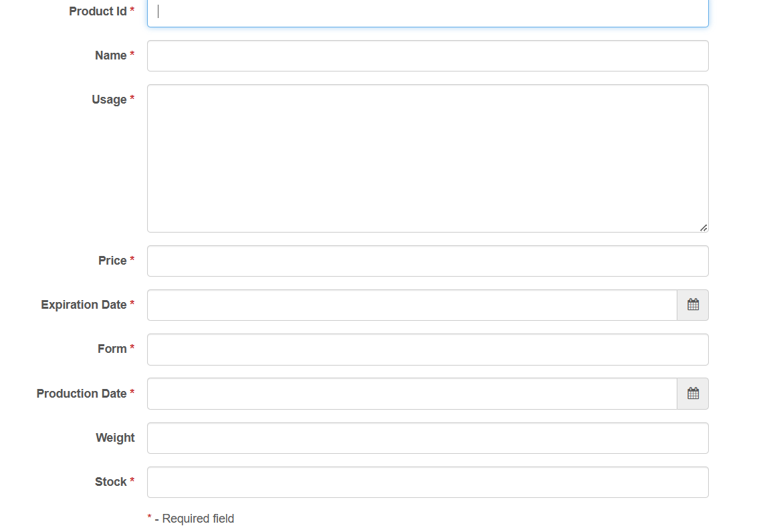

When the employee inserted the information and repeated the same ID, an error message will appear at the bottom of the page because the ID is a primary Key.

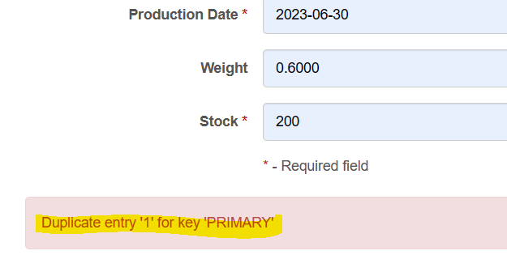

When the employee inserted the information and left some fields empty, the error message will appear and tell him that some filed are required and must be filled and must not be left empty.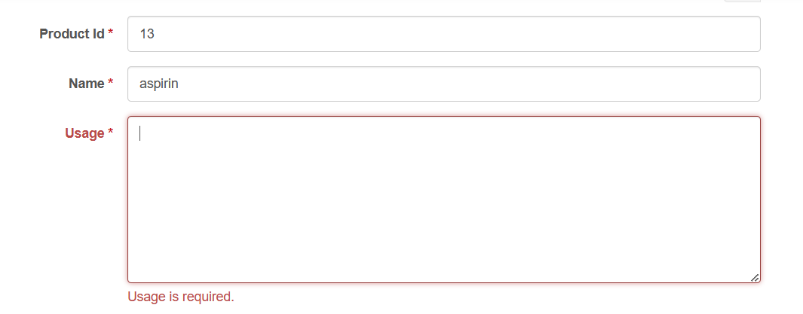

In case the employee wants to edit the information, the page below will appear

If the employee wants to export the information as PDF, he/she should click on export button then the page bellow will appear 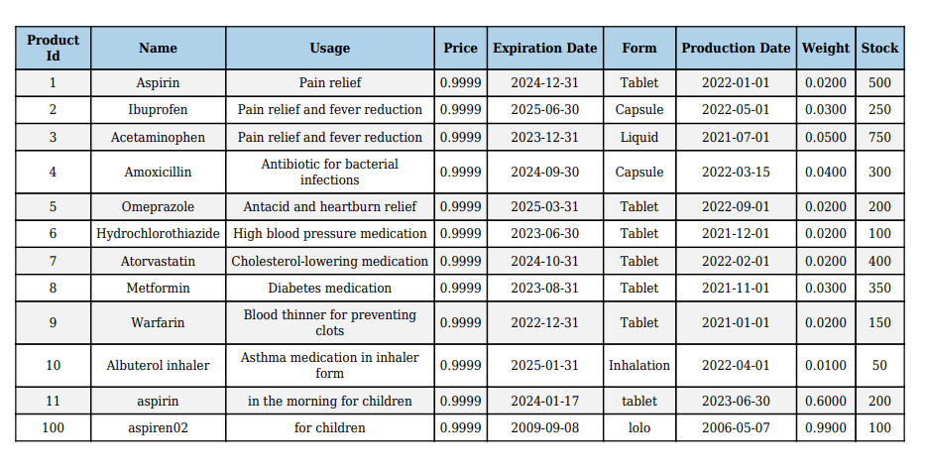

**Transaction page**

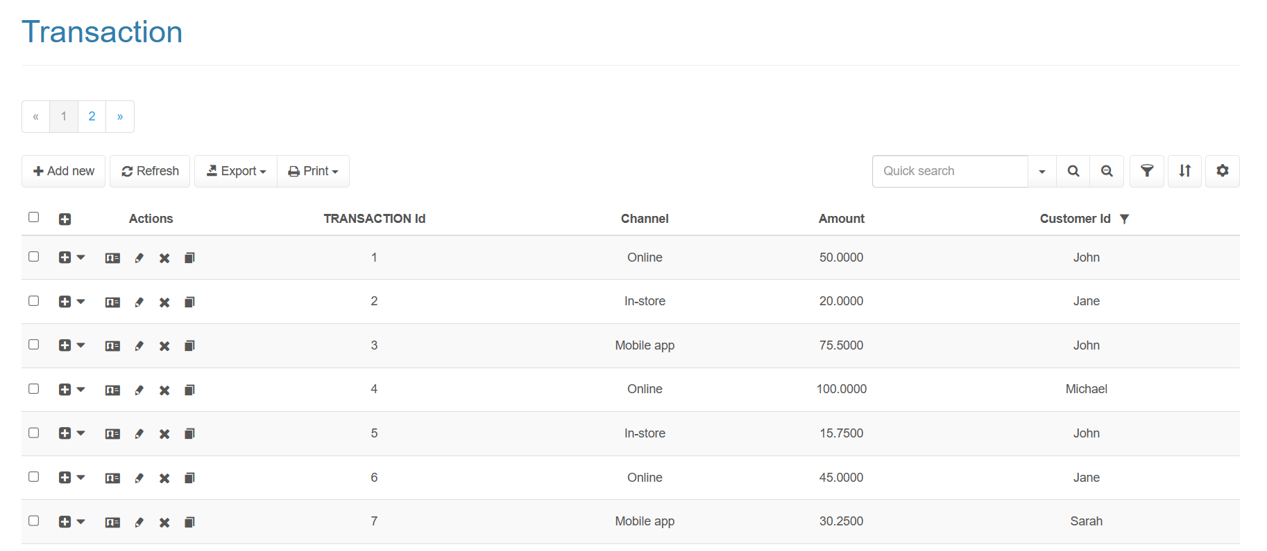

In this page if the employee clicks on  button, this page will appear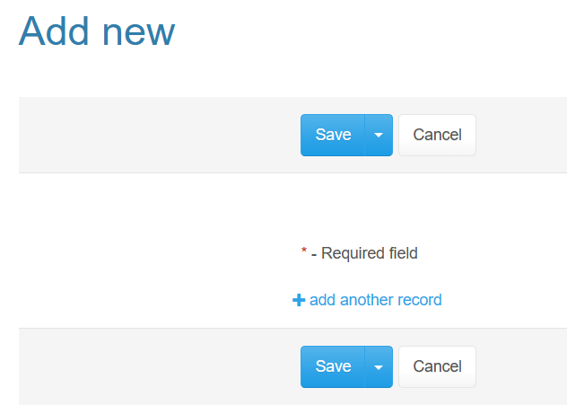

Which means the employee in transaction page only can view, and print information. He/she can’t insert information.

If the employee clicks on edit button, this page will appear 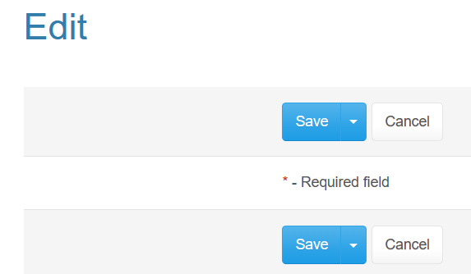

Which means the employee in transaction page can’t information.

The employee should know about this feature that there is still more information in other pages.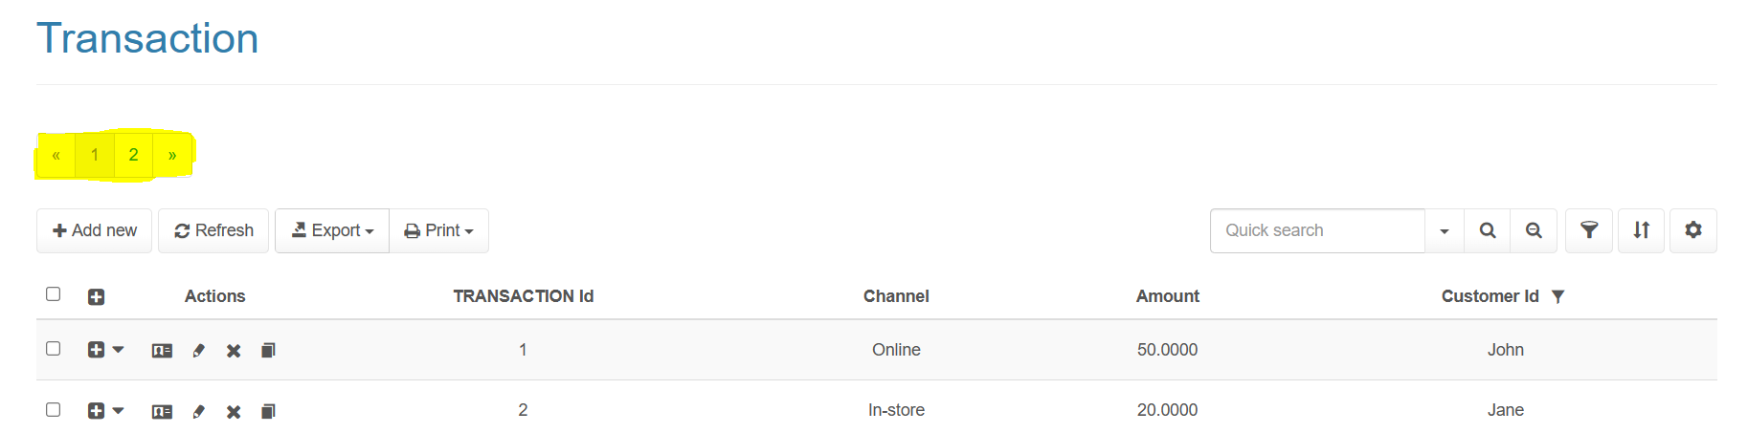

**Transaction product page**

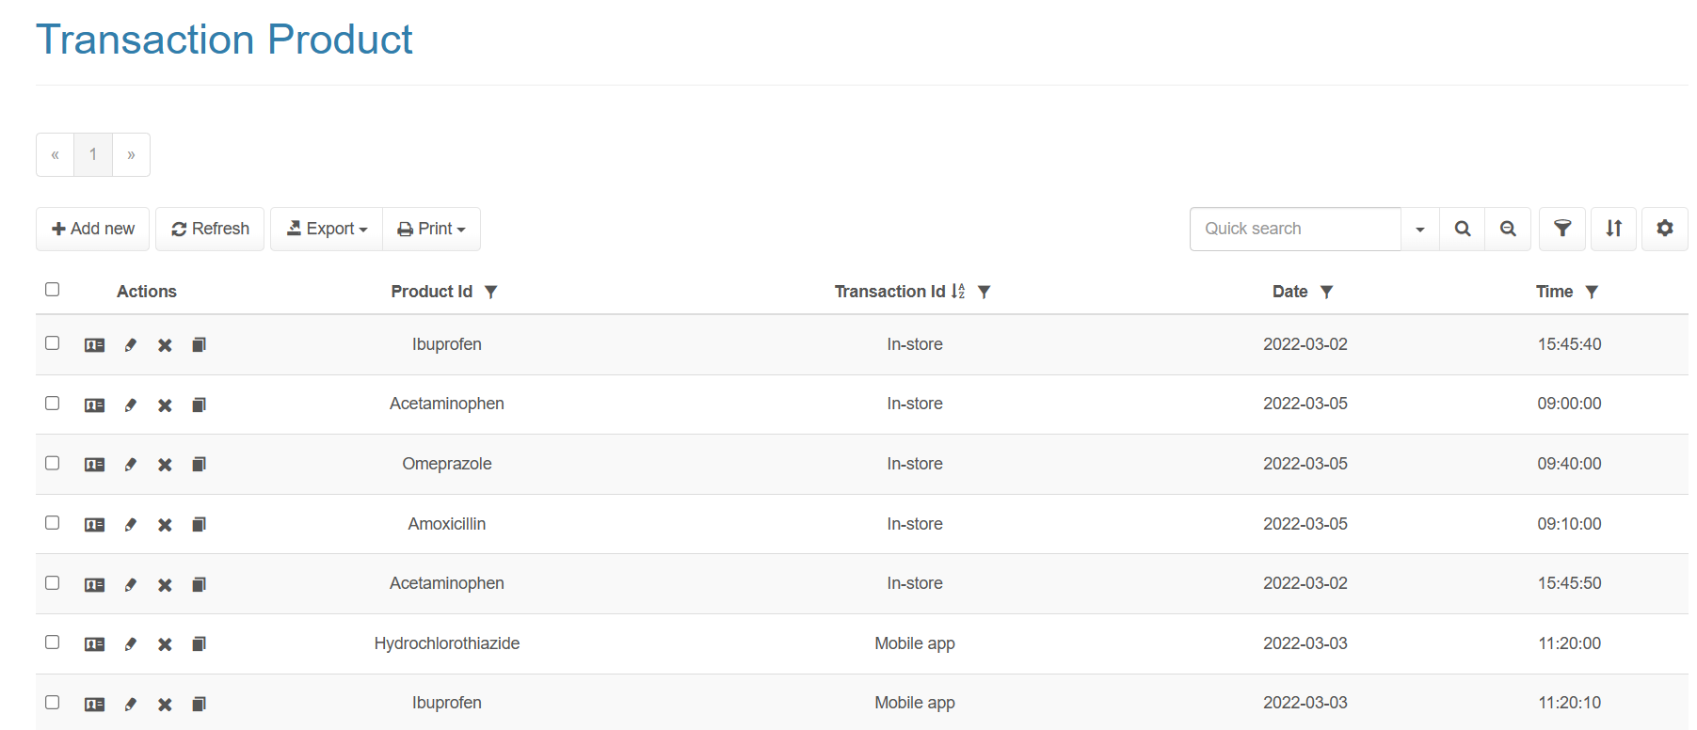

In this page if the employee clicks on  button, the page will appear

Which means that the employee in transaction product page only can view, and print information. He/she can’t insert information.

If the employee clicks on edit button, the page bellow will appear 

Which means that the employee in transaction product page can’t edit information.

## Frequently asked questions

**The first question 🡪** How can I go to the page that I want without pressing on the pack button and going to the home page or passing throw all the pages?

**The answer** 🡪 in the above of all pages there is a navigation bar which contains all the pages which you can see so you can press on the name of the page of your choice, and it will lead you directly to this page that you want.

**The second question 🡪** how can I access data quickly and choose the data that I want?

**The answer 🡪** any column Is arranging randomly if you press on the name of the column you will get ascending or descending arrangement and so it is easier to see the data you want.

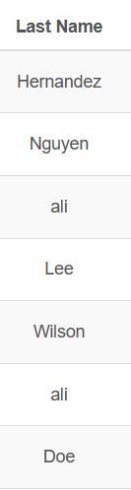

**The third question 🡪** Can I delete information and how?

**The answer 🡪** some pieces of information can be deleted such as the information related to the medicine. But an unfortunately at the moment the website has a problem with the delete button and we will fixe the problem as early as possible.

**The fourth question 🡪** why I can’t insert or edit some information such my degree, level, and salary??

**The answer 🡪** because some pieces of information are sensitive and only the manger is authorized to deal with them by inserting or updating them.

**The fifth question 🡪** what are the available facilities of the system?

**The answer 🡪** you can easily navigate any page of the system by clicking on the settings button then choose the number of the rows in each page.

**The setting button:**

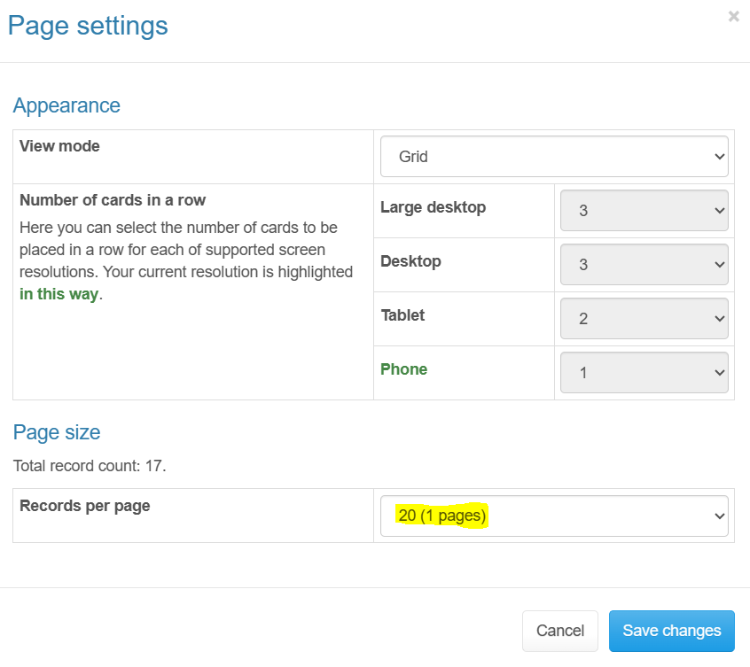

Dear user I hope I gave you clear explanation about the points that you asked about which were not clear in my website. For more information and questions, please visit our website or contact with our support team.

## Contact information

Dear customer we hope that you benefited from the explanation and the instruction above and you are always welcome to see more clarification and explore more information if you still need more help or have any question. Don’t hesitate to contact our support team to deal with any unsolved problems or continue any discussion. We greatly appreciate your feedback or suggestions about our system and services or any improvements. you can keep in touch with these **contacts information:**

**Emails:** [layannsaeed@yahoo.com](mailto:layannsaeed@yahoo.com)

**Phone number:** free number 🡪 0785050230

We really appreciate you participation and ready to help you and thank you for choosing out website. We look forward to hearing from you soon.